Ideation Phase

Define the Problem Statements

|  |  |
| --- | --- |
| Date | 22nd JUNE 2025 |
| Team ID | LTVIP2025TMID59454 |
| Project Name | LearnHub: Your Center for Skill Enhancement |
| Maximum Marks | 2 Marks |

**Customer Problem Statement Template:**

Many students, especially those in remote areas, struggle to access quality and affordable education in emerging technologies due to the lack of relevant courses in their local regions. At the same time, passionate individual educators face difficulties in sharing their knowledge, as most existing online learning platforms either charge high fees or favor large institutions. Working professionals also find it challenging to upskill because current platforms often lack flexibility and self-paced learning options. These challenges create a gap in the education ecosystem, leaving learners frustrated and educators underrepresented. Therefore, there is a strong need for an inclusive, affordable, and flexible online learning platform like LearnHub, where learners can access skill-based courses in the language they prefer, at their own pace, and educators can create and manage content independently at low cost—making skill enhancement accessible to all.

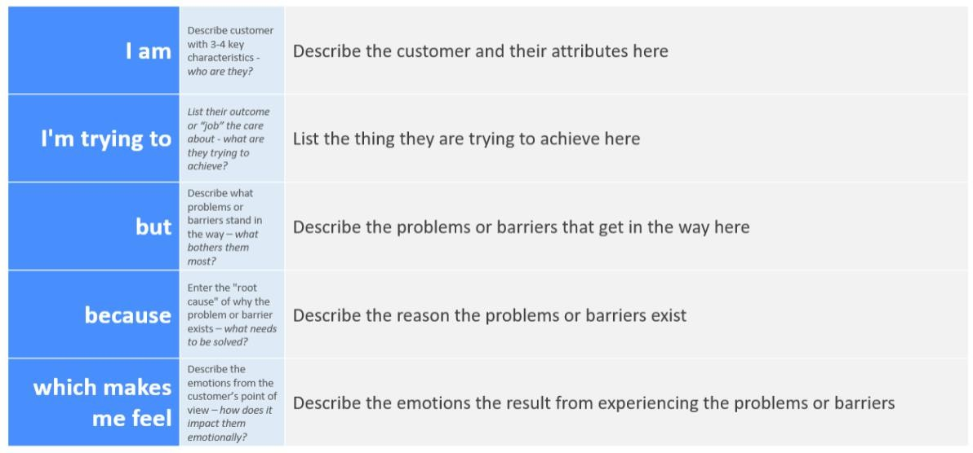

Reference: https://miro.com/templates/customer-problem-statement/

**Example:**

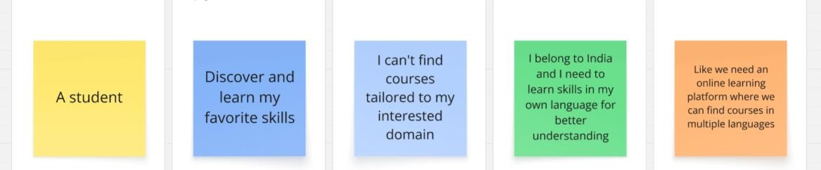

|  |  |  |  |  |  |
| --- | --- | --- | --- | --- | --- |
| **Problem Statement (PS)** | **I am (Customer)** | **I’m trying to** | **But** | **Because** | **Which makes me feel** |
| PS-1 | A college | Learn in- | I can't | I live in a | Like we need an online |
|  | student | demand technical | find relevant | remote area where | learning platform that is accessible, |
|  |  | skills like web | or | physical | affordable, and |
|  |  | development | affordabl e courses | classes are limited and | available in multiple regional languages |
|  |  |  | in my | most |  |
|  |  |  | region | platforms |  |
|  |  |  |  | are |  |
|  |  |  |  | expensive or |  |
|  |  |  |  | in unfamiliar |  |
|  |  |  |  | languages |  |
| PS-2 | A | Share my | I can’t | Most | Like we need a |
|  | passionate | knowledge | reach my | popular | platform where |
|  | individual | and provide | target | platforms | independent educators |
|  | educator | affordable | learners | prioritize big | can easily create, price, |
|  |  | training | easily on | institutions | and manage their own |
|  |  | sessions to | big | or require | courses with low cost |
|  |  | students | platforms | high commission | barriers |
|  |  |  |  | fees |  |